EXPERIMENT 6
Execute and display the results for the following commands in Kali Linux Operating Systems:
touch command
Pwd command
Wget command
AIM : To execute and study the touch,Pwd, and Wget commands in the Kali Linux operating system and observe their outputs.
DESCRIPTIONS
1. touch Command
The touch command is used to create a new empty file. It can also be used to update the date and time of an existing file.
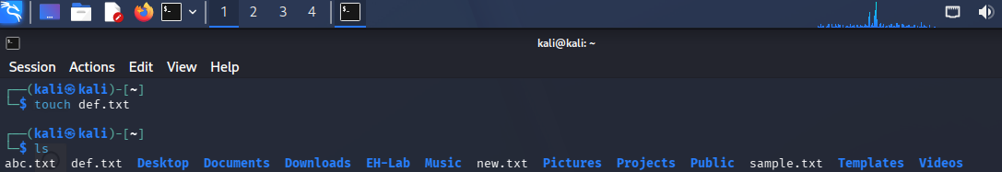
2. Pwd Command
The pwd command stands for Print Working Directory. It displays the complete path of the directory in which you are currently working.
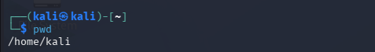
3. Wget Command
The wget command is used to download files from the Internet using a URL. It is commonly used to download web pages, documents, images, and other files.
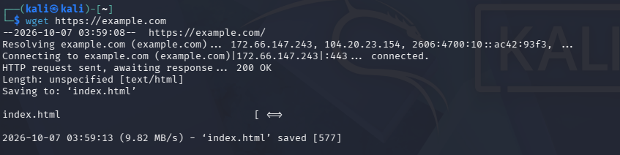
RESULT : The touch, pwd, and wget commands were successfully executed in Kali Linux. The touch command was used to create a new file, the pwd command displayed the current working directory, and the wget command successfully downloaded a file from the Internet.

